3. Adjusting Entries: 3. Abatements

Abatements are a deduction from the full amount of taxes. They are performed as a result of a Board of Civil Authority decision. You may decrease amounts due for Principal, Interest, Penalty and Other with this option. This will decrease the amount due without changing the amounts billed. This option could create a credit to be moved to another account.

Abatements will reduce the A/R and produce an expense to the town if you are using accrual based accounting. Abatements will make no entries to the linked General Ledger accounts if you are using cash based accounting.

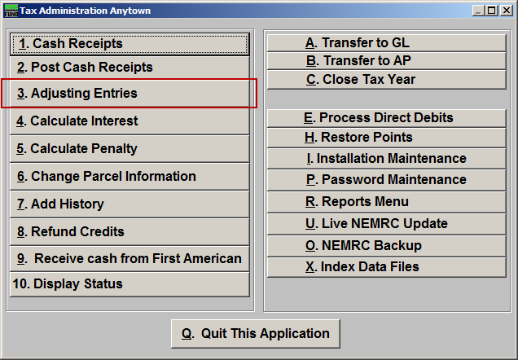
Click on “3. Adjusting Entries” from the Main Menu and the following window will appear:

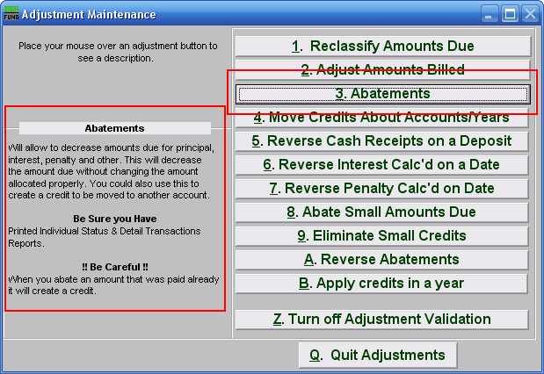
Consider the description that appears when you place the mouse over “3. Abatements.” Click “3. Abatements” and the following window will appear:

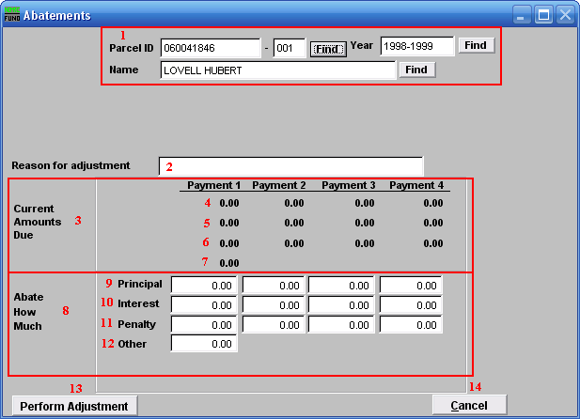
- Select the Parcel you are seeking. For additional information on finding Parcels, refer to TA GENERAL PARCEL LOOKUPS.

- Reason for adjustment: Type a reason for this adjustment. This is a required field.

- Current Amounts Due: These are the original amounts that were due.

- The original Principal due per payment.

- The original Interest due per payment.

- The original Penalty due per payment.

- The original Other charges due.

- Abate How Much: The amounts that you wish to Abate.

- Principal: How much you wish to Abate from the Principal amount per payment.

- Interest: How much you wish to Abate from the Interest amount per payment.

- Penalty: How much you wish to Abate from the Penalty amount per payment.

- Other: How much you wish to Abate from the Other amount per payment.

- Perform Adjustment: Click “Perform Adjustment” to complete this adjustment. Print a new Detail Transaction report and Status Report to follow the transactions applied.

- Cancel: Click “Cancel” to cancel and return to the previous screen.

